Exploratory Data Analysis and Visualization of

Airbnb Dataset

Ankit Peshin, Sarang Gupta, Ankita Agrawal

12/10/2018

Introduction

**The analysis task.**

The purpose of this analysis is to perform exploratory data analysis as well as data visualization to understand how different factors influence the demand of the listing properties on Airbnb.

**Problem**

Since its inception in 2008, Airbnb has been a major disruptive force in the gigantic hospitality industry, redefining the status quo of travel for consumers all around the world. By using Airbnb the guests and hosts can expand on traveling possibilities and present a more unique, personalized way of experiencing the world. The observations and insights will be useful for future analysis and decision-making related to Airbnb. and also provide useful information for travelers and hosts in this city.

**Description of data:**

**Listing_id :-** This is a unique identifier for each listing in the dataset.

**Listing_name :-** This is the name or title of the listing, as it appears on the Airbnb website.

**Host_id :-** This is a unique identifier for each host in the dataset.

**Host_name :-** This is the name of the host as it appears on the Airbnb website.

**Neighbourhood_group :-** This is a grouping of neighborhoods in New York City, such as Manhattan or Brooklyn.

**Neighbourhood :-** This is the specific neighborhood in which the listing is located.

**Latitude :-** This is the geographic latitude of the listing.

**Longitude :-** This is the geographic longitude of the listing.

**Room_type :-** This is the type of room or property being offered, such as an entire home, private room, shared room.

**Price :-** This is the nightly price for the listing, in US dollars.

**Minimum_nights :-** This is the minimum number of nights that a guest must stay at the listing.

**Total_reviews :-** This is the total number of reviews that the listing has received.

**Reviews_per_month :-** This is the average number of reviews that the listing receives per month.

**Host_listings_count :-** This is the total number of listings that the host has on Airbnb.

**Availability_365 :-** This is the number of days in the next 365 days that the listing is available for booking.

**Correlation of parameters**

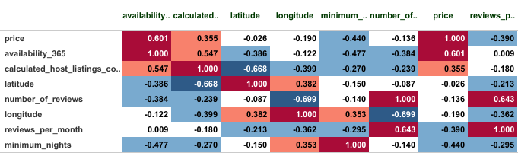

**The Outcomes**

From our investigation of the Airbnb NYC dataset, we found that the neighborhood, room type, and number of listings owned all have a relationship with the price of a listing.

Manhattan and Brooklyn have the highest demand for Airbnb rentals, as evidenced by the large number of listings in these neighborhoods. This could make them attractive areas for hosts to invest in property.

The average price of a listing in New York City is higher in the center of the city (Manhattan) compared to the outer boroughs. This could indicate that investing in property in Manhattan may be more lucrative for Airbnb rentals.

But Manhattan and Brooklyn have the largest number of hosts, indicating a high level of competition in these boroughs.

The data suggests that Airbnb rentals are primarily used for short-term stays, with relatively few listings requiring a minimum stay of 30 nights or more. Hosts may want to consider investing in property that can accommodate shorter stays in order to maximize their occupancy rate.

The majority of listings on Airbnb are for entire homes or apartments and also Private Rooms with relatively fewer listings for shared rooms. This suggests that travelers using Airbnb have a wide range of accommodation options to choose from, and hosts may want to consider investing in property that can accommodate multiple guests.

The data indicates that the availability of Airbnb rentals varies significantly across neighborhoods, with some neighborhoods having a high concentration of listings and others having relatively few.

The data indicates that there is a high level of competition among Airbnb hosts, with a small number of hosts dominating a large portion of the market. Hosts may want to consider investing in property in areas with relatively fewer listings in order to differentiate themselves from the competition.